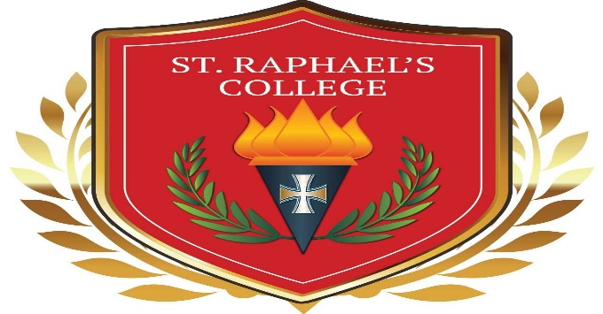

1st YEAR STUDENT AWARDS 2020
ACADEMIC AWARDS:
Colm Campbell & Aoife Faherty
MUSIC AWARD:
Howard Moreira
ART AWARD:
Ivan Urbanovics
SPORT AWARDS:
Leah O’Halloran & Vincent Morgan
ACHIEVEMENT AWARDS:
Meghan Kielty, Yvonne Kostova, Aoife Morahan, Caoimhe McClearn, Callum Ryan, Maeve McClearn, Saoirse Ward, Yxian Cao, James Spellman, Niamh Kelly.
MERCY AWARDS
Lily Burke, Aoife Morahan, Caoimhe Quane, Arthur Kelly, James Spellman

