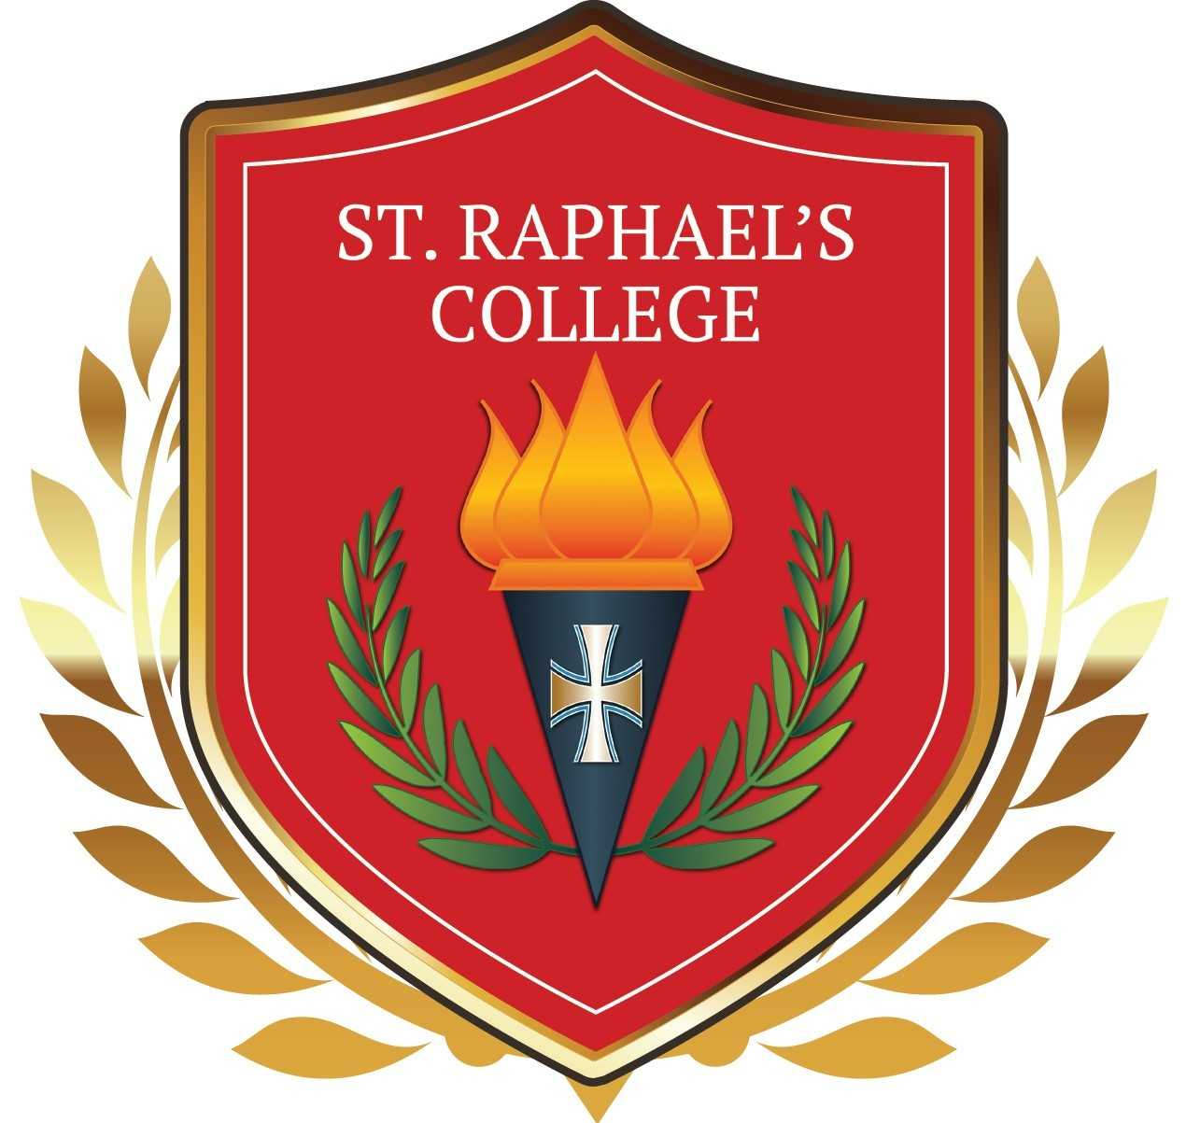

St. Raphael’s College
Loughrea, Co. Galway

Relationships and Sexuality Education (RSE) Policy

January 2019

St. Raphael’s College

Title
Relationships and Sexuality Education (RSE) Policy
Introductory Statement
This RSE policy was developed in accordance with:
1. Our mission statement.
2. Guidelines as set out in Circular M4/95, M20/96, C23/10 Social and Personal Health Education (SPHE) and Relationships and Sexuality Education-Best Practice Guidelines for Post Primary Schools, C37/2010 and C43/2018.
3. Guidance from SPHE Department.
4. Consultation with the Care Team.
5. Consultation with CEIST.
All members of the College community are consulted during its development. These include the parents through the Parents Association, the teachers, the students in the form of the Student Council and the Board of Management.
This RSE policy is a written statement of the aims of the RSE programme within St. Raphael’s College. The policy reflects the relationship of RSE to SPHE and other subjects e.g. Religious Education, Science, Biology, Physical Education and Home Economics and the organisation and management of RSE within the college.
Scope
This policy applies to all aspects of teaching and learning about relationships and sexuality.
It also applies to all school staff, students, parents/guardians, visiting speakers, invited guests, volunteers and members of the Board of Management.
Rationale
It is necessary to have an RSE policy as RSE is a key element of healthy social and personal development as:
• Young people are exposed to a wide variety of messages about sexuality and sexual activity. Schools in consultation with parents/guardians need to reflect on how to provide for the needs of their students.
• The Education Act 1998 requires that schools should promote the social and personal development of students and provide health education for them.
• Section 4 of the Rules and Programme for Secondary schools requires schools to have an agreed policy for RSE and a suitable RSE programme in place for all students at both Junior and Senior cycle. At Junior Cycle the RSE programme is part of the Social, Personal and Health Education (SPHE). At Senior Cycle the RSE Programme is part of the Religious Education programme.
• Circulars M4/95, M20/96, M22/00, M11/03, M27/2008, M37/2010 request schools to commence a process of RSE policy and programme and to implement them for all students from First Year to Leaving Certificate.
Access to sexual and health education is an important right for students under the terms of the article 11.2 of the European Social Charter. The Council of Europe European Committee of Social Rights has indicated it regards this Article as requiring that health education “be provided throughout the entire period of schooling” and that sexual and reproductive health education is “objective, based on contemporary scientific evidence and does not involve censoring, withholding or intentionally misrepresenting information, for example as regards contraception or different means on maintaining sexual and reproductive health”.
• The effectiveness of an RSE programme is dependent on a collaborative policy process involving teachers, parents/guardians, members of the board of management and students.
Relationships to characteristic spirit of the school (school’s mission/vision/ aims)
• The RSE policy will reflect the educational philosophy of CEIST and the core values and ethos of the school, as outlined in the school’s mission statement.
• Spiritual, moral and religious issues will arise when teaching RSE. The RSE policy will guide teachers in the treatment of such issues in accordance with the ethos of the college. It is important that teachers of RSE understand that their role is to express the views of the whole school community on these sensitive issues and not their own personal views. In this regard, it should be noted that:
• Schools are required to deliver all aspects of the RSE curriculum, including those in relation to sexual orientation, contraception, sexually transmitted infections etc. This can be done within a context in which teaching of the programme is informed by the school’s ethos.
• A school can express its ethos while at the same time facilitating students in discussing a range of views in relation to topics within the RSE programme.

Aims and Objectives
This RSE policy intends to achieve the following:

Aims:
- To help young people understand and develop friendships and relationships.
- To promote an understanding of sexuality.
- To promote a positive attitude to one’s own sexuality and in one’s relationship with others.
- To promote knowledge of and respect for reproduction.
- To enable young people to develop attitudes and values towards their sexuality in a moral, spiritual and social framework.
Objectives:
RSE should enable students to:
- Acquire the understanding and skills necessary to form healthy friendships and relationships.
- Develop a positive sense of self awareness, and the skills for building and maintaining self-esteem.
- Become aware of the variety of ways in which individuals grow and change especially during adolescence and to develop a respect for difference between individuals.
- Understand human physiology with particular reference to the reproductive cycle, human fertility and sexually transmitted infections.
- Understand sexual development and identity and explore aspects of sexuality including sex role stereotyping, gender issues and cultural influences on sexuality.
- Value family life and appreciate the responsibilities of parenthood.
- Develop strategies for decisions and actions consistent with personal moral integrity and respectful of the rights and dignity of others.
- Develop skills for coping with peer pressure, conflict and threats to personal safety.
Key Measures
A. Provision of Training and Staff Development
• Arrangements regarding the deployment of staff will be made by the Principal. Consideration will be given to gender balance. However, it would be preferable to consult with and timetable teachers who express an interest in teaching SPHE/RSE. All teachers involved in this work do not have to be “experts” on the issues concerned. However, they do require sensitivity to the needs of the group, an ability to deal with questions openly/honestly and preparedness to refer to more expert advice if necessary. The skills acquired in general teaching apply also to RSE.
• In service training for the teaching of RSE will be provided by the SPHE support service. Staff will be encouraged to attend by the Principal.
• The appropriate teaching resources will be made available to staff subject to budget constraints.
B. Inclusion of Parents/Guardians
• Parents /Guardians are the primary educators of their children and their role in education concerning relationships and sexuality education is seen by the college as very important. Relevant sections of this RSE policy will be included in the Parent’s information pack on enrolment to the college, a letter regarding the policy and reference to the policy will be in the student journal. In Senior Cycle, a letter will be sent home at the beginning of the Module. The policy will be available to view on the school website
• The policy has been designed in consultation with the Parents’ Association representatives and the views expressed by parents will be taken into account when the policy is being reviewed. A copy of this policy will be made available to any parent/guardian on request to the school office.
Note: The Education Act 1998 (section 30, subsection (20) (e)) provides that a student is not required to attend instruction in any subject which is contrary to the conscience of the parents or in the case of a student who has reached the age of 18, the student. Hence, parents /guardians have a right to opt their child out of the sensitive issues in RSE if they wish to do so. Parents do not have to give reasons for withdrawal. Once a parent’s/guardian’s request to withdraw is made, that request must be complied with until revoked by the parent. Parents/Guardians are required to collect and supervise their child at this time.
C. Ethical/Moral Considerations
RSE is a complex area of the curriculum. A school’s RSE policy will provide guidance for teachers on the moral and ethical framework within which the programme will be taught. Issues include the following:
Answering Questions:
• While it is important to create an environment in SPHE/RSE in which students can discuss issues openly, teachers may not be able to answer all questions asked by students and can set appropriate limits. Students may ask questions about issues which are not included in the curriculum. On these, and on all questions, teachers will use their professional judgment, guided by the age of the students, the RSE curriculum and the RSE policy for the school. Students should be made aware at the beginning of the RSE programme that asking personal questions of staff and peers is inappropriate and unacceptable.
Confidentiality:
• While students should not be encouraged to disclose personal or private information in SPHE/RSE classes, there may be times when they do talk about their own lives. Confidentiality should be respected unless a teacher becomes aware that a student is at risk, in which case the appropriate action should be taken e.g. follow the procedures set down in the Child Protection Procedures and Guidelines for Post-Primary Schools (2011), notify parents etc.
In cases of under-age sexual activity, p. 10 of the Child Protection Procedures for Primary and Post-Primary Schools (2011) state: ‘In all cases where a school becomes aware of underage sexual intercourse the school shall take appropriate steps to inform the child’s parents. (2.1.6)’.
It is important that the students must be made aware of the limits of confidentiality and that teachers do not give unconditional guarantees of confidentiality. Teachers may refer back to the ground rules agreed at the start of their SPHE programme. Students must be aware that any incident may be conveyed to the Principal(DLP) and possibly the parents /guardian if the Principal(DLP) decides that it is in the best interests of the child. Teachers will inform students when the content of a conversation can no longer be kept confidential.
Sexual Activity:
• It is advisable for teachers to give young people information on the age of consent which, following the passage of the Criminal Law (Sexual Offences) Act, 2006, is 17 years of age for both males and females.
Family Planning/ Contraception:
• The post-primary RSE Curriculum Guidelines state that the subject of family planning should be covered within the Senior Cycle RSE programme. There is a lesson on family planning in the RSE Senior Cycle Resource Materials on p.77. The RSE programme requires that young people are provided with information about methods of contraception, including Natural Family Planning. Age appropriate information is already taught as part of the Junior Certificate Science Curriculum. Schools can use their discretion with regard to the age at which students receive any aspect of the RSE programme.
Sexual Orientation:
• The post-primary RSE Curriculum Guidelines include the subject of sexual orientation. There is a lesson on sexual orientation in the RSE Senior Cycle Resource Materials on p.151. RSE training courses delivered by the SPHE Support Service provide teachers with further materials.
• The school may decide if the topic needs to be addressed before Senior Cycle, especially if LGBT+ bullying is an issue. Teachers do not promote any one lifestyle as the only acceptable one for society. Therefore, it is inevitable and natural that LGBT+ will be discussed during a programme of sex education.
• One of the many advantages of exploring issues concerning homosexuality is the opportunity to correct false ideas, assumptions and address prejudice. Discussion of homosexuality should be appropriate to the age of the pupils.
• The Equal Status Act 2000 and the Equality Act 2004 prohibit discrimination across nine grounds, including sexual orientation. Consideration needs to be given to the messages that are conveyed if the subject of homosexuality is not discussed in schools.
• It is important that any student who is coming to terms with their sexual identity should not experience any harassment, embarrassment or isolation which may impact on their mental and emotional health and they should be offered support from the Care Team.
Abortion:
• This topic will be dealt with in an age appropriate, open manner, looking at all aspects of the issues in a non-directive way in line with the States legislation and CEIST ethos.

Sexually Transmitted Infections (STIs):
• While awareness of STIs is one of the objectives of the Second Year SPHE/RSE syllabus, STIs are mainly addressed in Senior Cycle. There is a lesson on STIs in the RSE Senior Cycle Resource Materials on p.103. Given that rates of STI transmission are increasing, it is important that the subject is addressed in schools.
Visiting doctors and nurses are available from the local doctor’s surgery, Portiuncula Hospital, Ballinasloe and University Hospital Galway.
D. Practical Issues
• All students in Junior Cycle have one period of SPHE per week. RSE will be included as a module in the second term of school as part of their SPHE programme.
• Students in senior cycle will receive a minimum of 6 weeks tuition in RSE as part of their Religious Education programme.
• The size of the class groups will be determined by the base class.
• Students will be taught all aspects of RSE together.
• The boundaries of the RSE programme will be delivered with due deference to:
(a) The age of the students.
(b) The CEIST ethos.
(c) Limits of confidentiality, limits to discussions and questions.
(d) Ensuring that the RSE classroom is a safe place for all, including students and teachers.
(e) RSE curriculum guidelines.
• Visiting speakers must be made aware of the schools RSE policy, Mission statement and the SPHE visitor guidelines as laid down by the Department of Education in circular 0023/2010 to secondary schools. The Care Team are advised when visiting speakers are in the College. Thus, classroom teachers must remain in the classroom with the students; parents should be consulted and made aware of visiting people and agencies. All programmes and events delivered by visitors and external agencies must use appropriate evidence based methodologies with clear educational outcomes. Such programmes are best delivered by those specifically qualified to work with young people for whom the programmes are designed.
• Provision will be made for students with Special Educational Needs as laid down by the NCCA guidelines. To comply with these guidelines, it will be necessary for the class teacher to consult with the Special Needs Co-ordinator, prior to the programme, to discuss any students with special needs and to ascertain how they can be supported throughout the programme.
• Consideration and sensitivity must be given to the needs of students with special circumstances, e.g. students who may be pregnant.
• Once a parent’s/guardian’s request to withdraw a student is made, that request must be complied. Parents/Guardians are required to collect and supervise their child at this time.
Links to other Policies and to Curriculum Delivery
School policies need to be consistent with one another, within the framework of the overall School Plan. Relevant school policies already in place, being developed or reviewed, will be examined with reference to the RSE Policy and any implications which may impact upon them will be addressed. Similarly, the implications of other school policies and guidelines/plans for the RSE policy also need to be considered.
The following policies may be among those considered:
- Child Protection Policy
- Guidance Plan
- Anti-Bullying Policy
- Substance Use Policy
- Acceptable internet usage Policy.
Identify any links to curriculum delivery
• Social, Personal and Health Education (SPHE) is a Junior Cycle core subject. SPHE provides students with opportunities to develop the skills and competencies to care for themselves and others and to make informed decisions about their health, personal lives and social development. This includes providing information on relationships and sexuality.
• Aspects of RSE are delivered across the curriculum, through subjects such as Religious Education, Science, Biology, Physical Education and Home Economics. In St. Raphael’s College our aim is to ensure that all students receive a full and balanced RSE programme from First Year through to Leaving Cert.
Implementation, Arrangements, Roles and Responsibilities
• The Wellbeing Committee may be assigned the role of coordinating the implementation of the policy.
• Teaching Staff will have direct responsibility for delivering the RSE programme at Junior Cycle and Senior Cycle.
• Year Heads have a Pastoral care role in liaising with students, parents/guardians, Chaplain, Guidance Department, Special Educational Needs Co-ordinator and CEIST personnel.
Ratification & Communication
When the finalised policy is ratified by the Board of Management, it becomes the College’s agreed RSE Policy. The RSE policy will be circulated within the school community. A copy of the RSE policy will be available to staff and parents on the school website. Reference to the policy will also be in the staff handbook and in the student journal. The entire teaching staff will familiarise themselves with the policy and make themselves aware of any changes implied in curriculum delivery.
Parents/guardians will be informed of the RSE Policy from the time of acceptance of the student (Admissions Policy).
A copy of the RSE policy will be available at all times in the college office and on the school’s Website.
Implementation Date
The policy will apply from 7th February 2019/2021.
Monitor the Implementation of the Policy
The Principal is responsible for the implementation of the policy but may assign the monitoring to the RSE staff.
Reviewing and Evaluating the Policy
The policy will be revised as necessary in the light of legislative changes and evaluation will take place within the framework of school review.
The policy will be reviewed at 2 year intervals or sooner if necessary. Some practical indicators will be used to gauge the impact and effectiveness of the policy. Such indicators include the following:
• A student /teacher evaluation form may be given to some classes at the end of the RSE module.
• The range of resource material available to teachers.
• The in-service training availed of by teachers.
• Students awareness of the policy in their school journal.
• Parents and Guardians are made aware of the policy.
• Feedback from teachers, students, parents/guardians and members of the Board of Management will inform this review.

Policy Completed January 2019
Policy explained to Care Team January 2019
Policy explained to Student’s Council January 2019
Policy agreed by Staff January 2019
Policy agreed by Parent’s Council January 2019
Policy ratified by Board of Management February 2019
Next review date: February 2021.

Date of Implementation
Signed: ______________________________ Chairperson, BOM

